**Practical 4**

**Aim: Draw Use case and Activity Diagrams for the project definition.**

* **Use Case Diagram:**

A Use Case Diagram is a high-level visual representation of how users (actors) interact with a system to accomplish specific goals. It provides an overview of the functional requirements of a system and helps stakeholders understand how different users engage with its functionalities.

* **Key Elements of a Use Case Diagram**

1. Actors – External entities (users, systems) that interact with the system.
   * Example: In an online shopping system, a customer is an actor who places orders.
2. Use Cases – Actions or functions that actors can perform within the system.
   * Example: “Place Order,” “Track Delivery,” “Manage Inventory” in an ecommerce system.
3. System Boundary – Defines the scope of the system by separating internal system components from external actor.

* **Relationships in Use Case Diagrams**

1. Association – A direct link between an actor and a use case (solid line).

* + Example: A customer interacts with the “Place Order” use case.

1. Include – When one use case always requires another use case (dashed arrow with "include"). o Example: “Process Payment” is always included when a customer places an order.
2. Extend – When a use case may add optional functionality to another use case (dashed arrow with "extend"). o Example: “Select Seat” extends “Book Flight” if the customer chooses to select a seat.
3. Generalization – When one use case is a specialized version of another.
   * Example: “Rent Car” and “Rent Bike” generalize to “Rent Vehicle”.

# Purpose and Benefits

* Clarifies System Scope **–** Helps in defining what isinsideandoutsidethe system.
* Easy Communication– Helps developers, analysts,and stakeholdersunderstandsystem functionalities.
* Identifies User Requirements **–** Provides astructured approach to defining how users interact with the system.

Example: Online Shopping System

* Actors: Customer, Admin, Payment System
* Use Cases: Place Order, Track Delivery, Process Payment
* Relationships: Customers place orders, orders require payment, and admins manage inventory

* **Use case diagrams for Online Job Portal**

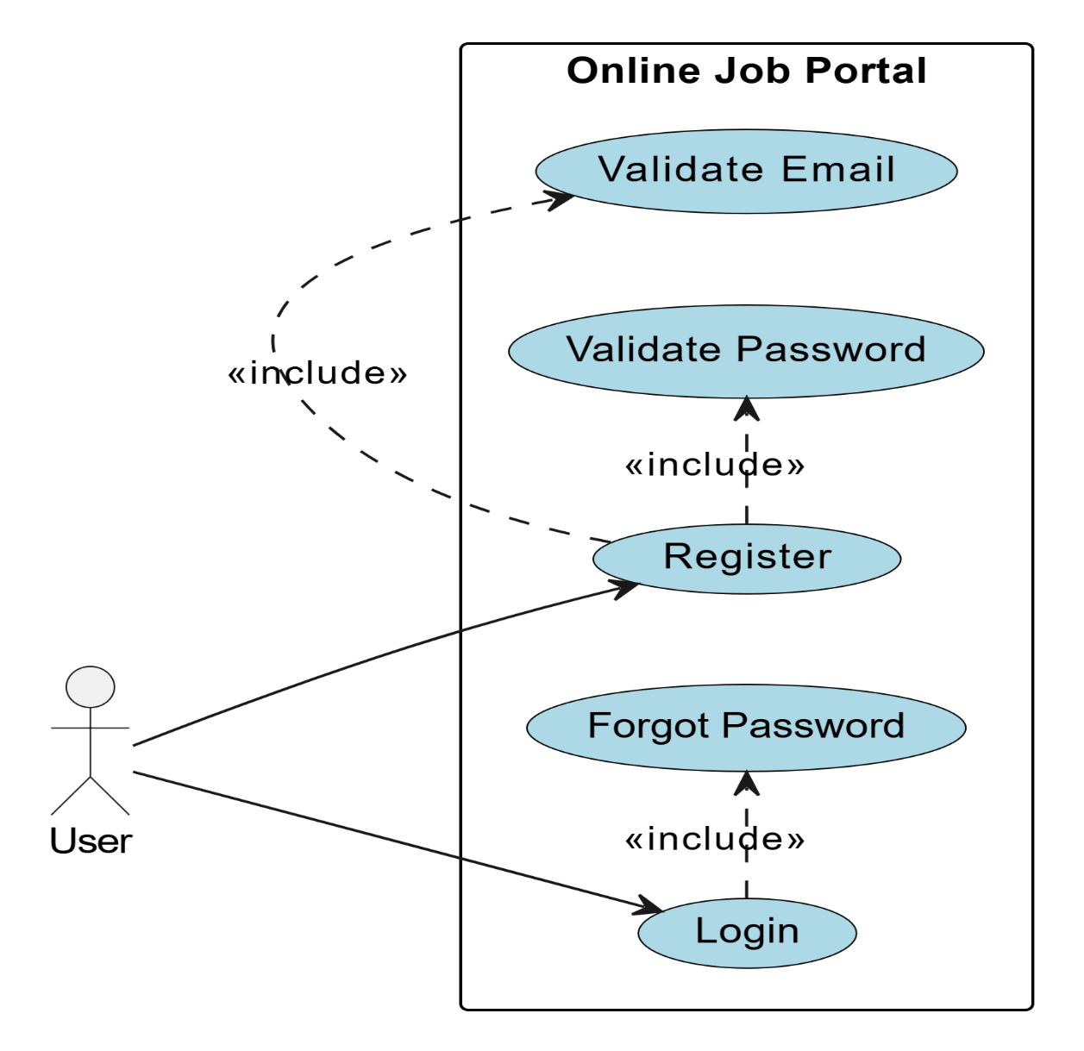

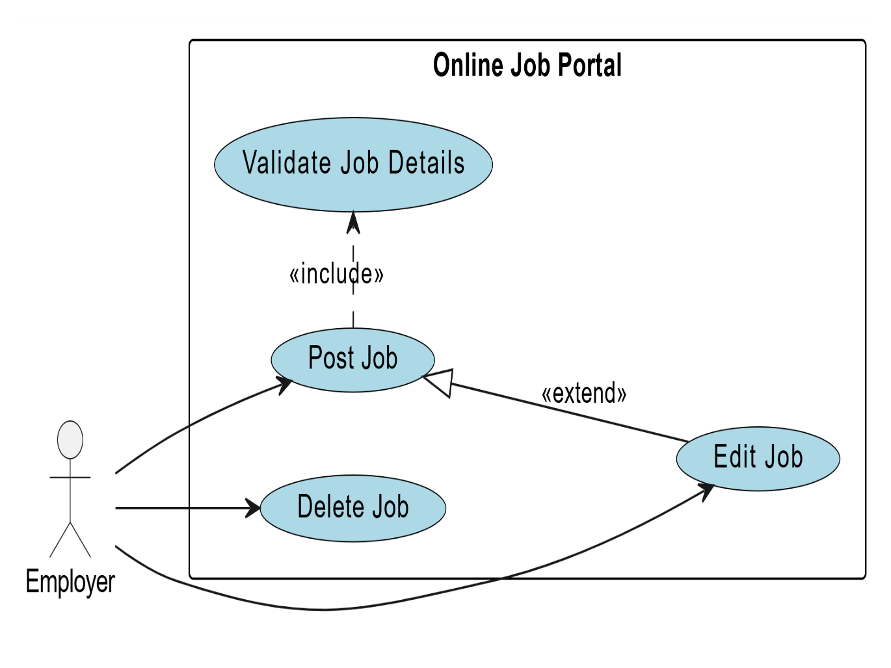

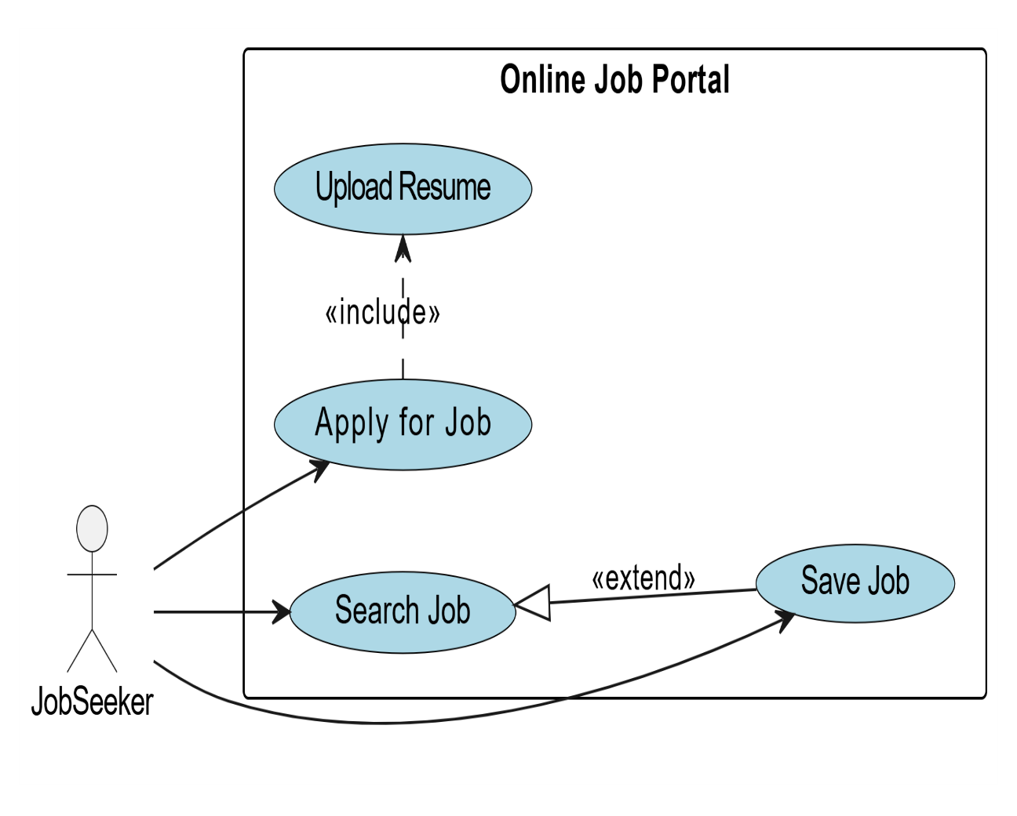

* **Activity diagram:**

An Activity Diagram is a type ofUnified Modelling Language (UML) diagram used to visually represent the workflow or process flow within a system. It helps in understanding the sequence of activities, decision-making points, and interactions between various components.

* **When to Use an Activity Diagram?**

Modelling workflows **– Helps in mapping out** business processes or system workflows**.**

Understanding system behaviour **– Shows how a system moves** from one state to another**.** Decision-making processes **– Visualizes conditions where** different actions **may occur based on choices.**

Concurrent or parallel processes **– Depicts multiple activities happening** simultaneously

# Key Notations in Activity Diagrams

1. Initial State – Represents the starting point of a workflow (black filled circle).
   * Example: When a user opens an application, that is an initial state.
2. Activity (Action State) – Represents a specific task or action (rounded rectangle).
   * Example: “Login,” “Submit Form,” or “Process Payment.”
3. Control Flow (Action Flow) – Represents transitions from one activity to another (arrows).
   * Example: Clicking "Submit" moves the process to "Verify Payment."
4. Decision Node – Used when a choice needs to be made (diamond shape).
   * Example: If a payment is successful, proceed to "Order Confirmation"; otherwise, show "Payment Failed."
5. Guard Conditions – Conditions written on decision arrows [inside square brackets] to define path selection.
   * Example: [If Age > 18] → Proceed to Registration.
6. Fork (Parallel Execution) – Splits a process into two or more concurrent tasks (thick black bar).
   * Example: "Process Order" divides into "Notify Seller" and "Update Inventory."
7. Join (Synchronization) – Combines multiple parallel paths back into a single flow.
   * Example: After "Pack Items" and "Generate Invoice," move to "Ship Order."
8. Merge Node – Used to merge multiple flows into one (diamond shape, without condition).
   * Example: Whether a user chooses "Credit Card" or "PayPal", both paths lead to "Payment Confirmation."
9. Swim lanes – Divides the diagram into sections to indicate which entity performs which activity.
   * Example: In a banking system, activities are split into Customer, Cashier, and Bank Server.
10. Final State – Marks the end of the process (black circle inside another circle).

* **Activity diagrams for Online Job Portal:**

